**TORNADOES in the USA REPORT**

Professor Elena Strange

Submitted: April 6, 2019

Presented: April 9, 2019

By Catherine Romanova and Kieran Croucher

**Problem Statement and Background:**

Each year, storms and other examples of extreme weather result in large numbers of injuries or deaths, and cost millions in property damage. Studies have shown that there is a solid correlation between global warming and the frequency/intensity of storms, as gas emissions from the general population increases the atmosphere’s capacity for water vapor, thereby creating conditions more prone to severe storm formation (UCSUSA). One such example of dramatic weather are tornadoes, and for this project, we investigated the relationship between the number of tornadoes and fatalities in the USA, hypothesizing that as the number of tornadoes per year increases, the number of deaths would also increase.

The data used to determine the validity of our hypothesis was extrapolated from the National Oceanic and Atmospheric Administration (NOAA). Our data was found in two different CSV files, each taken from 1998 to 2018, resulting in 42 separate files. The first data type was “Storm Details”, which described every documented storm (tornadoes, thunder, flood, etc.) in a single year including its date, time, location, storm type, reporter, and a brief description. The next piece of data was “Storm Fatalities”, which gave a list of every injury or fatality within a single year caused by any type of storm, describing the date, time, location, whether or not the incident was a death or injury, and finally the gender and age of the person involved. This data provided a comprehensive and detailed account of all the information required to conduct an in-depth analysis of the proposed research question.

**Introduction and Description of the Data:**

Tornadoes and the threat they pose were a stimulating topic for us to focus on, largely in part because of the looming danger of global warming and its effects on our climate. In recent years there has been a dramatic increase in violent storms and extreme weather phenomenon, and tornadoes are no exception to that category. As of now, approximately 17 million people occupy the ~500,000 square mile region of the USA known colloquially as “Tornado Alley” which covers eight states. Here tornadoes are a part of every day life, as each year the area is visited by an average of 1,000 tornadoes per year. The damage caused on people is not the only concern, as this region is the primary supplier for farmed food in the USA, providing for at least 300 million people (US Tornadoes). If the intensity and abundance of tornadoes in this region gets out of hand, the safety of citizens both living in and outside of it could be threatened. Considering all this information, it was our opinion that this project could be considered relevant and impactful to many people, including but not limited to residents of tornado-prone regions, meteorologists, construction workers, and government officials. Using this data, scientists and activists alike could pose effective solutions. Immediate remedies might include more effectual storm-predicting technology and efficient safety protocols in the presence of storms. Looking to the future, we hope to see more enhanced research in the field of climate change/meteorology, as well as a better understanding of the imminent threat of global warming and its ramifications. Luckily, there are already organizations in place to share knowledge on these issues, such as the NOAA.

The NOAA was officially founded in 1970 through the merger of three individual agencies, the U.S. Coast and Geodetic Survey, the Weather Bureau, and the U.S. Commission of Fish and Fisheries. Together, their mission was to “understand and predict changes in climate, weather, oceans and coasts; to share that knowledge and information with others; and to conserve and manage coastal and marine ecosystems and resources.” (NOAA). Each year, this organization compiles colossal amounts of data on topics ranging from the fiery surface of the sun to the dark depths of the ocean, and such data includes tornadoes. From their data repositories we were able to learn about individual storms, lives lost because of them, and when cross referenced, we were able to effectively test our hypothesis.

**Methods:**

To set up our data for subsequent file processing, we initialized and stored data in two dictionaries, one for the storm details file, and the other for the storm fatalities file, each of which used the year in question to represent the key. The storm details dictionary’s value was a list of all the rows from the originating CSV file where the storm type was a tornado. The storm fatalities dictionary’s value was a list of all the rows from the CSV file where the cause of the fatality was listed as a tornado. In order to effectively process the data, we were required to utilize data cleaning approaches. For example, before adding the storm to the list of tornadoes for the storm details dictionary, we first had to check the row of the CSV file and confirm that the storm was a tornado. Additionally, when processing the storm fatalities CSV file, we first had to check that the storm ID of the incident being processed matched any storm ID already stored in the storm details dictionary, then verify that the incident was a fatality and not a documented injury. Once we had sufficiently cleaned and processed the data, we had to analyze it in an effective manner.

We first recorded the number of tornadoes for each year by counting the number of rows for each year of the storm details dictionary, and initialized a new dictionary to hold the results, whose key was the corresponding year and whose value was the total number of tornadoes for that year. Next, we recorded the number of fatalities per year by utilizing the same method above, counting the number of deaths per year, and storing the value in a dictionary whose key was the corresponding year. Finally, we had all of the data we required to draw our results and conclusions.

**Results, Conclusion, and Future Work:**

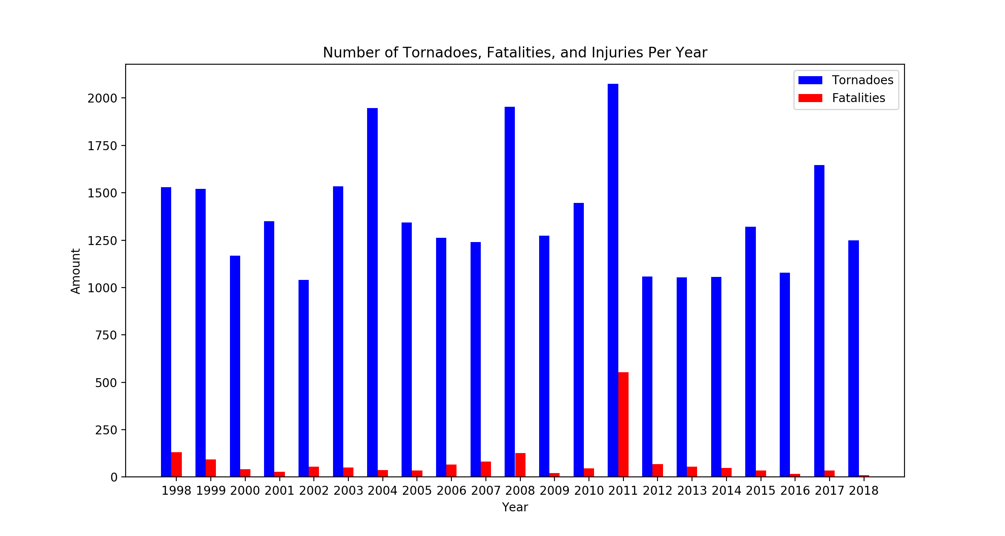

According to our results, in the past twenty years the number of fatalities has decreased, save for one outlier in 2011, with 553 deaths. For example, whereas there were 130 deaths in 1998, there were only 17 in 2016, 35 in 2017, and 10 in 2018. The resulting average rate of change is -6 deaths per year, indicating a decrease in the fatality rate of tornadoes. Additionally, the number of tornadoes occurring per year appears to be erratic, with varying highs and lows. Although the average rate of change appears to be negative, suggesting a decrease in the average number of tornadoes per year, there are many cases of a dramatic increase in tornado occurrences in a single year, high above the average number. These inconclusive results could be attributed to a relatively short time span.

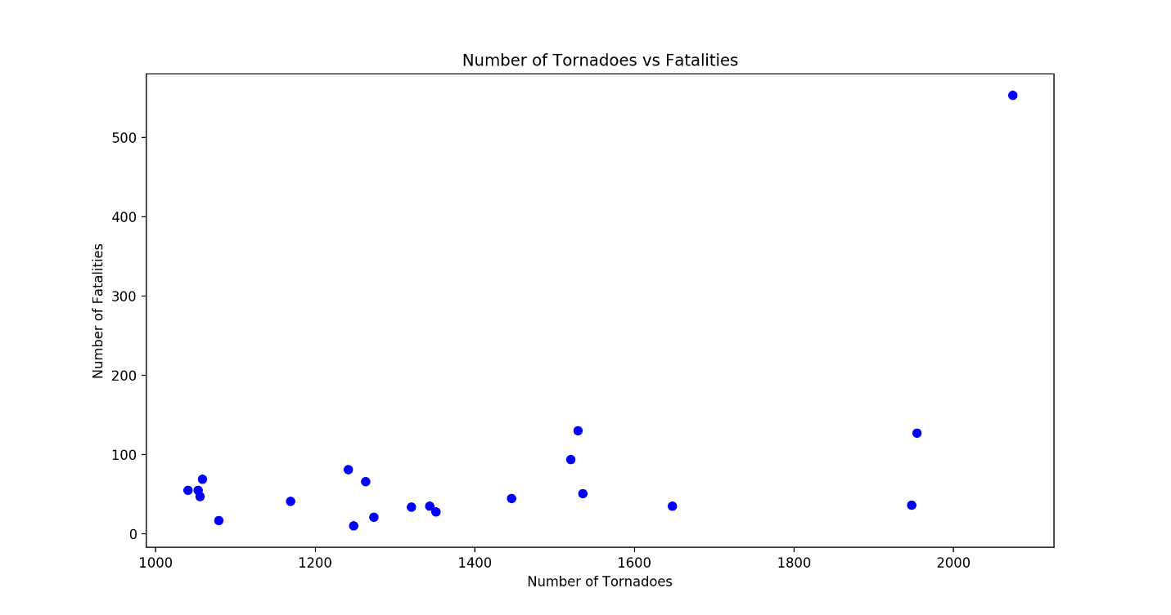

Additionally, according to the results above there seems to be a correlation to an increasing number of fatalities and number of tornadoes. When there are less than 1200 tornadoes, the death toll remains below 100, closer to 50. However, in years when the number of tornadoes grew to over 1500, it was not uncommon for fatalities to reach close to 150, and in 2011, there were more than 553 deaths.

In conclusion, our data indicates that the number of fatalities occurring from tornadoes has decreased in recent years, but that higher frequencies of tornadoes result in higher number of casualties. We were not able to prove that the number of tornadoes has increased over time however, because our data did not provide enough examples from previous years to demonstrate an average increase or decrease that could be supported by figures. These results therefore both agree and disagree with our initial hypothesis that the number of tornadoes would increase in time and with it, so would the number of fatalities. Our hypothesis was supported in the idea that higher numbers of tornadoes result in high number of fatalities but was wrong in assuming that the number of fatalities would increase over time.

There were many takeaways to consider at the end of our experiment. We were proud to show that our data seemed to prove that higher frequencies of tornadoes would result in more casualties, and that our chosen figures were effective in proving/disproving our hypothesis. However, there were some shortcomings in our project that we would like to address in a potential future revisit. For example, we were not able to demonstrate an increase/decrease in tornado frequency over time, likely due to our very limited range of time (only twenty years). In future projects we would like to dive back farther in the annals of NOAA recordings, potentially to its first entry in 1970. Another weakness to consider was the lack of representation for injuries caused by tornadoes. The reason we chose not to represent injuries in this project was that the NOAA failed to provide a sufficient amount of data listing all the injuries caused by each storm, as it is especially difficult to account for every injury. This could be remedied by cross referencing our data with repositories pulled from other sites, providing a more accurate summary. Considering these weaknesses, we believe that these issues could be easily addressed in the future and could build the foundation for a significantly larger project.

Looking forward, we would like to increase the scope of our project in future works by accounting for more storm varieties, such as hurricanes, floods, and blizzards. As awesome as tornadoes are, they make up only a tiny fraction of storms in the USA and have a significantly lower mortality rate than other cases of extreme weather. Initially our goal was to research the correlation between hurricanes and fatalities over time, not tornadoes. However, the NOAA did not list “hurricanes” as one of the storm types when compiling their data, likely due to the fact that hurricane fatalities are caused by a wide range of circumstances considered to be storms themselves, such as strong winds, flash flooding, hail, or even in some cases, tornadoes themselves. Considering this, it would have been difficult to record hurricane deaths, and easier to focus on a smaller storm such as tornadoes. Other storms could be easily represented in the future by utilizing the same data repositories or additional ones and initializing many more dictionaries to account for new storm types.

Works Cited

“Are Severe Rain Storms, Snow Storms, Drought, and Tornadoes Linked to Global Warming?” *Union of Concerned Scientists*, www.ucsusa.org/global-warming/science-and-impacts/impacts/global-warming-rain-snow-tornadoes.html.

Heberton, Brendan. “A Tornado's Cost: Living in a Tornado Alley.” *U.S. Tornadoes*, 17 Feb. 2016, www.ustornadoes.com/2014/04/24/a-tornados-cost-living-in-a-tornado-alley/.